IT2120 - Probability and Statistics

Name: Deneshkar. P

IT No: IT24103828

Exercise 1

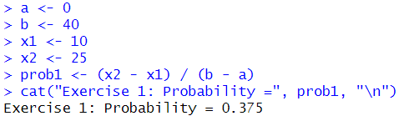

Exercise 2

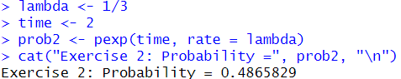

Exercise 3

